Taylor Larrechea

Dr. Gustafson

Math 365

April 21, 2018

MPA Student Showcase

Saige Dacuycuy

The first person that I talked to in this year’s student showcase was Saige Dacuycuy who is a physics major here at CMU. Saige’s senior research was focused on measuring very small currents (pico amp levels) through electronic devices. He measured two different kinds of electronic noise, shot noise and Johnson noise. With the data that he collected, he graphed Voltage against Resistance where the slope of the line through the data points would represent the Current in the circuit. Saige send he used this trendline to compare values to see how much of an error he was getting in his experiments. During his research he also found the charge on an electron and the Boltzman constant $k_{b}$. His research necessarily wasn’t based around modeling something, rather it was trying to precisely measure known constants and very small currents. His poster and a picture of me with him are below.

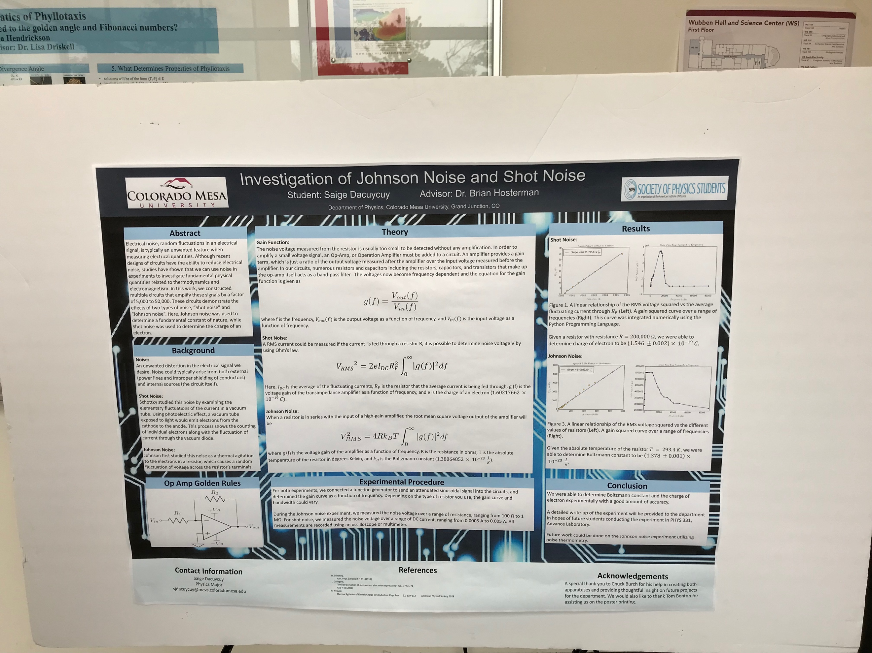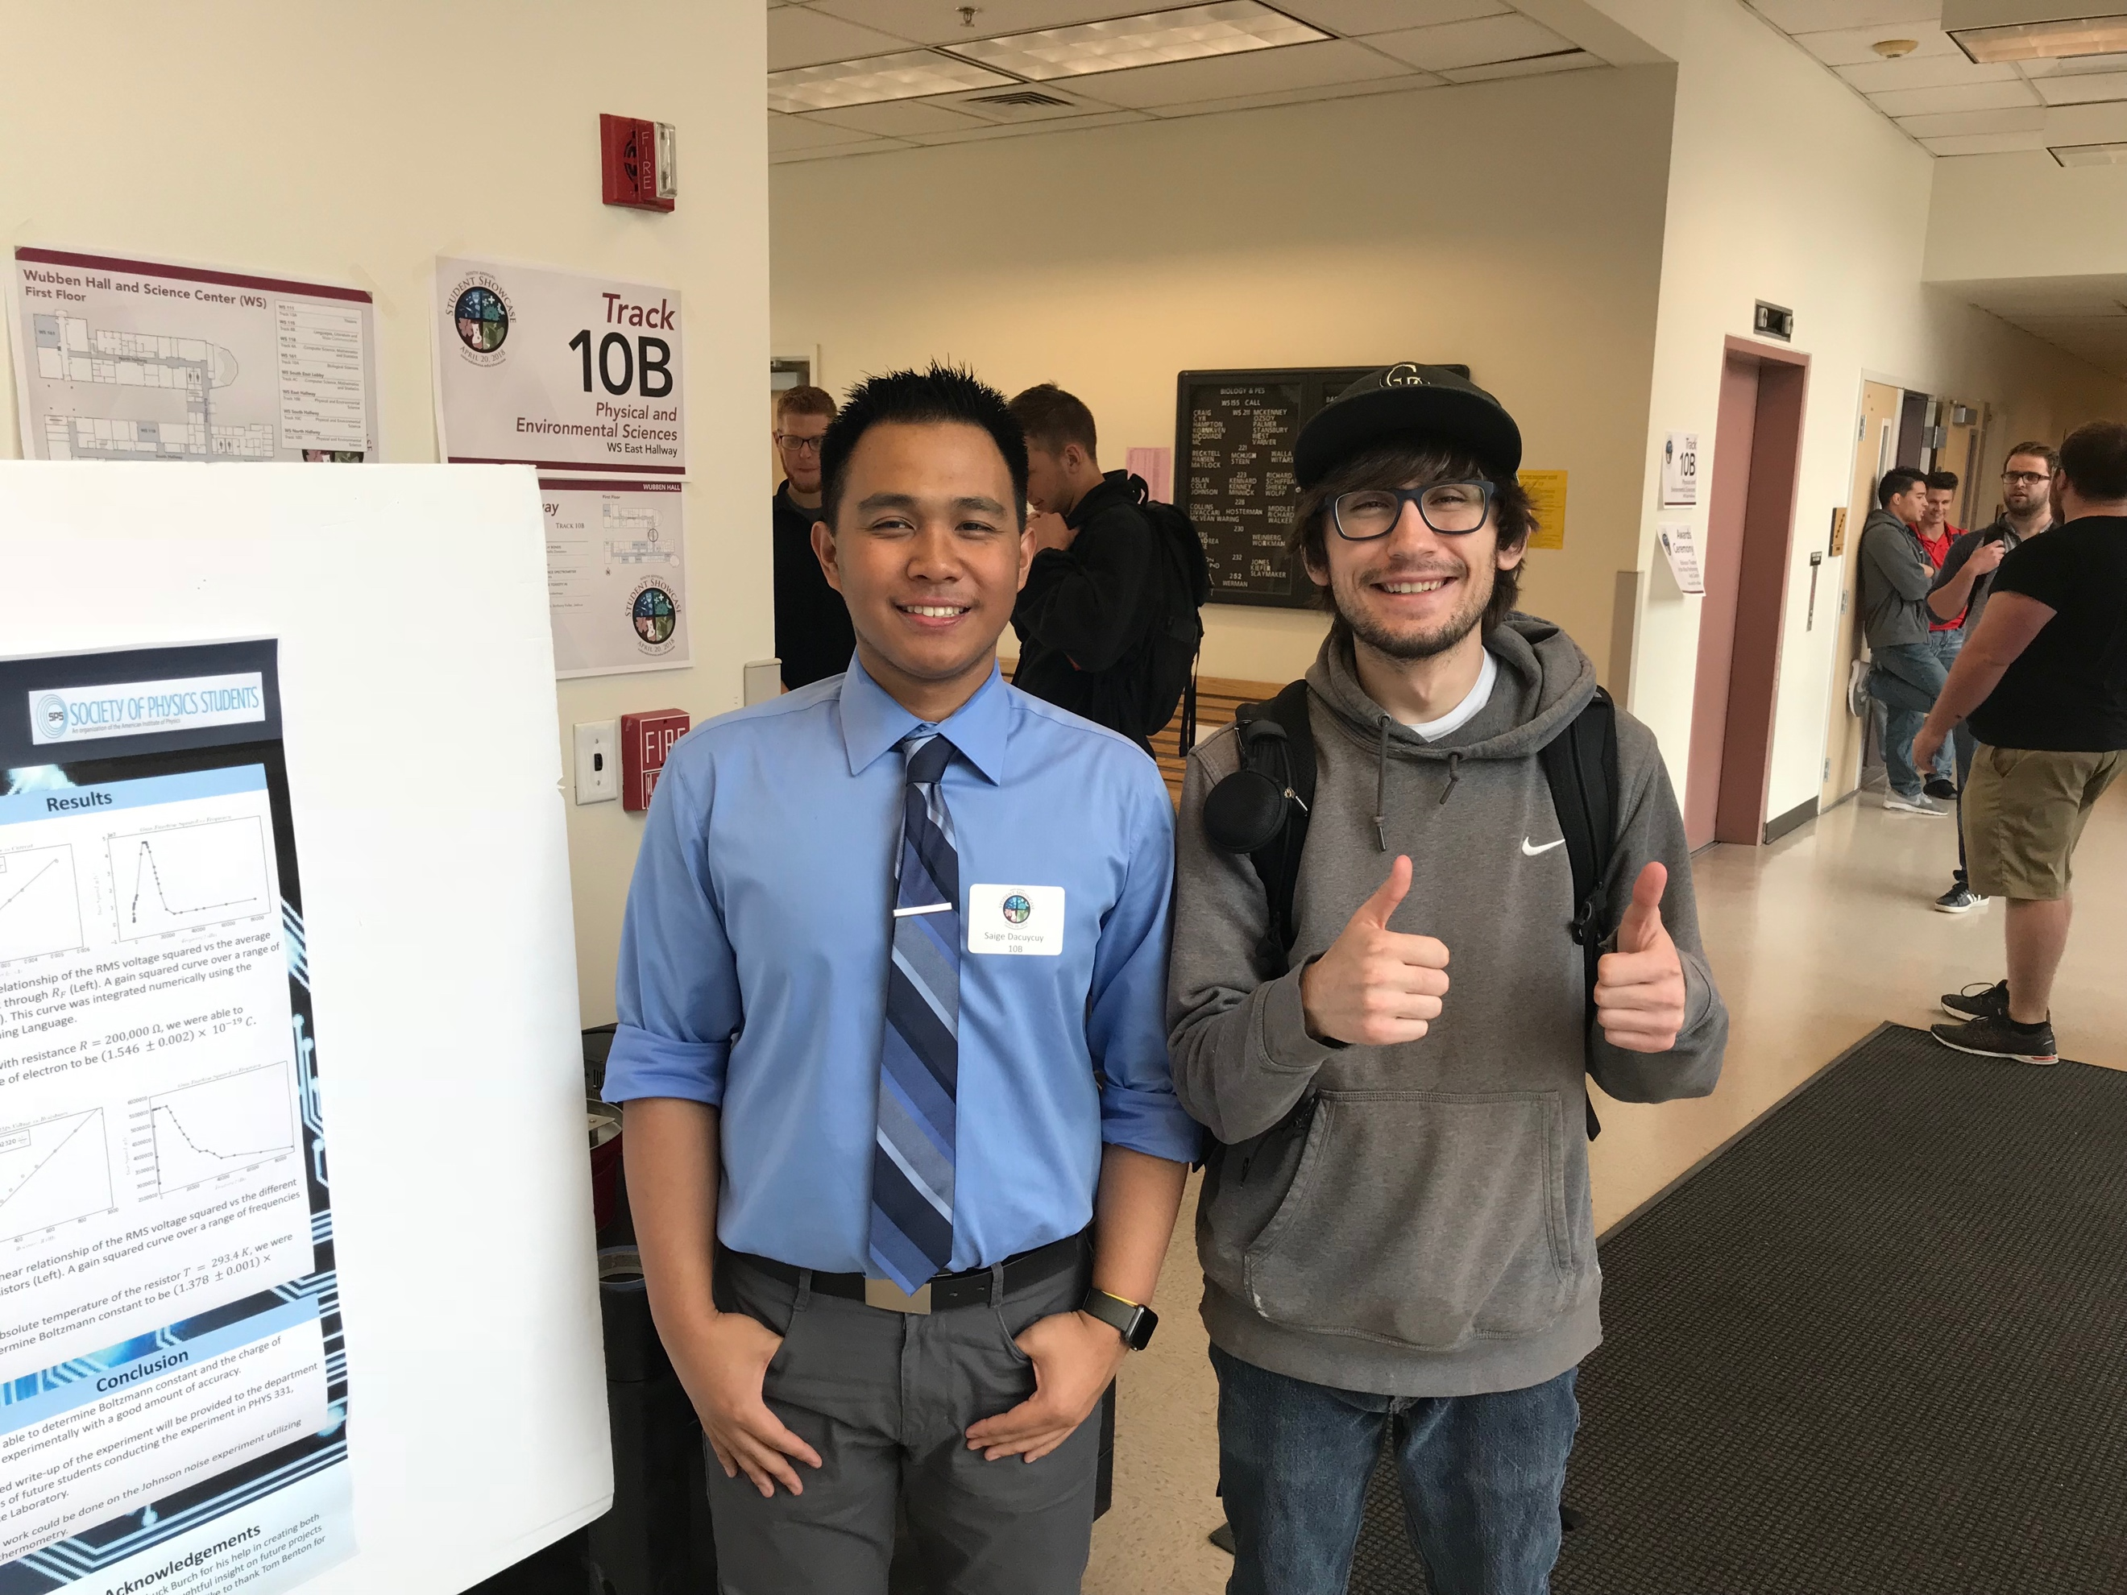

Haley Jensen

The second person that I talked to at the student showcase was Haley Jensen who is a statistics major here at CMU. Haley worked with the Jacksonville Jaguars over a summer and collected data to predict the score of the Jaguars based on the position of the field that they were on. She essentially was trying to model what a team should expect for points dependent upon their performance in a game. This of course would be a very useful tool for a football team. She continued on to explain that she used a type of regression called Loess regression and was a different kind of regression than what we use in this class. Haley mentioned that this type of regression analysis allowed for a better line of best fit and thus a better model for predictions. All of this can be seen in the picture below. I unfortunately forgot to take a picture with her after we got done talking.

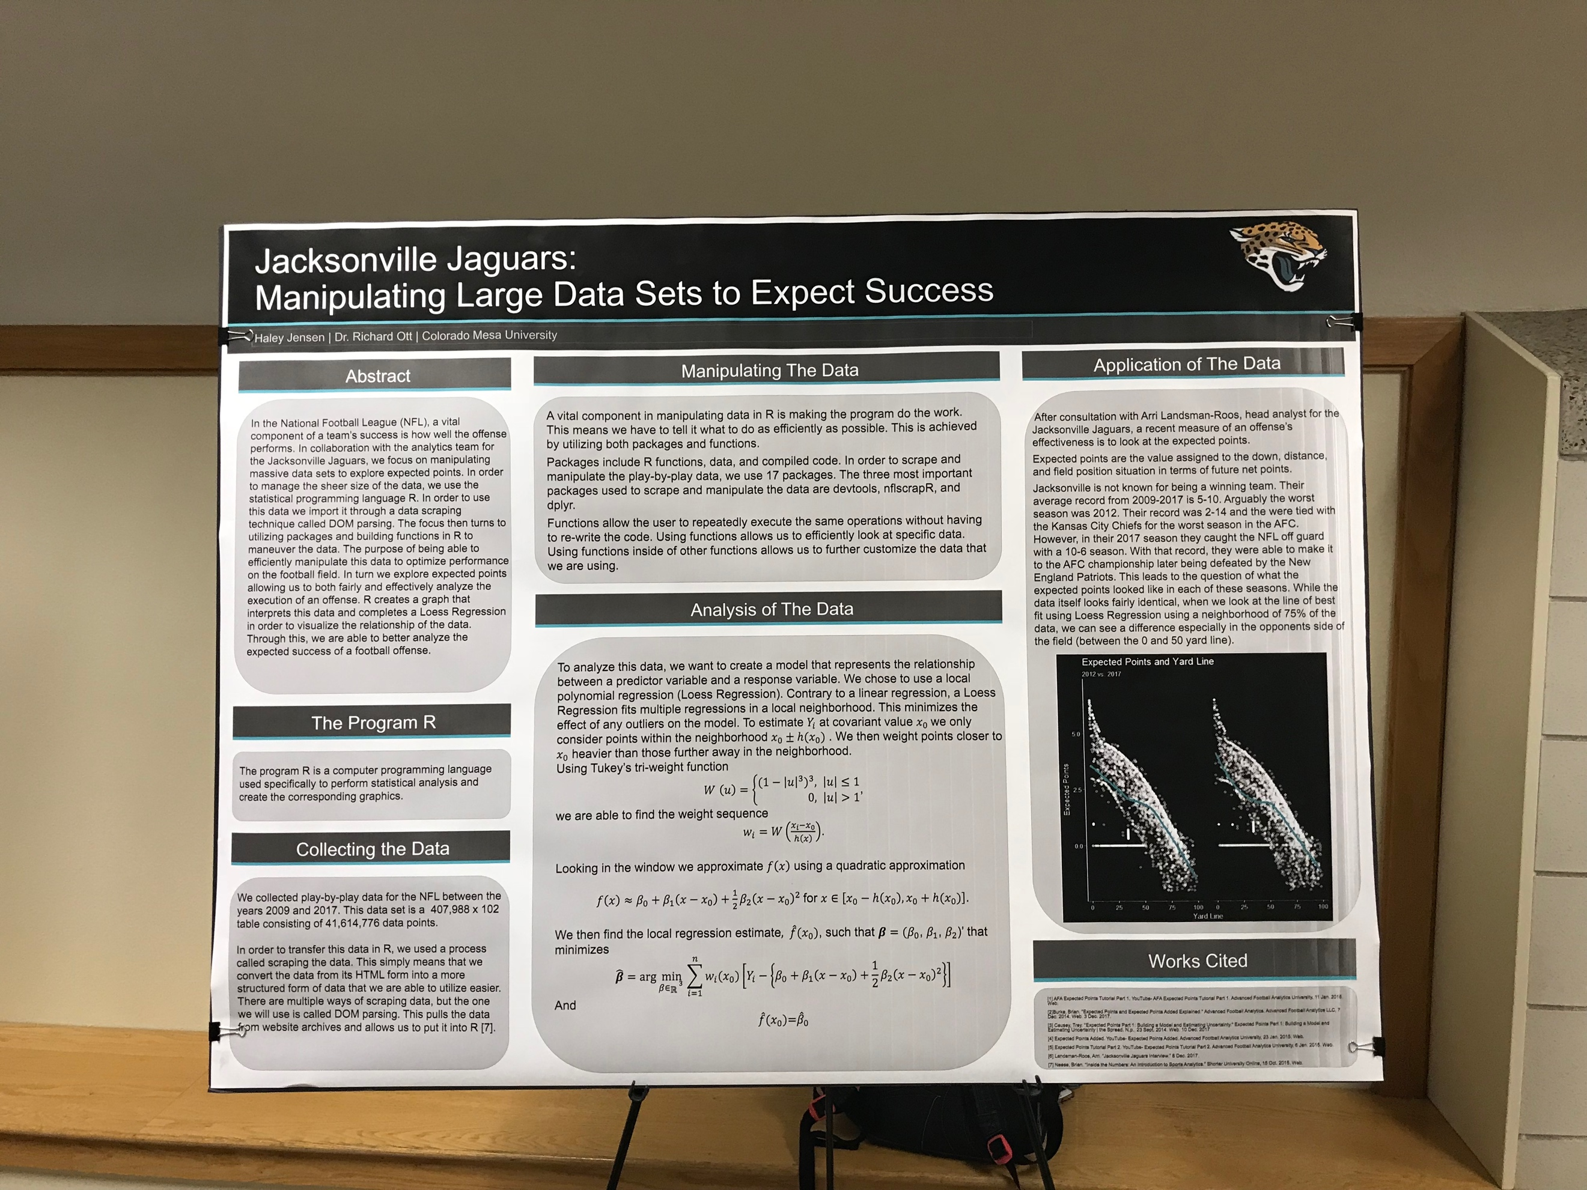

Note: I figured since I forgot to take a picture with some of the people I talked to, I’d do an extra person to make up for it.

David Gionco

David Gionco is a statistics major here at CMU and he did a project on the probability of being drafted into the NHL. The purpose of his model was to help NHL teams evaluate the probability of a draft pick playing in the NHL. Since some of the players who get drafted never play for a major league team this model is of great use to teams when drafting players. He had a best fit model for his data (which can be seen in his poster below) and this was the closest thing pertaining to our class that he did in his project. Like a lot of mathematical models there were a lot of variables that he took into play to calculate his probabilities that he was looking for. He used logistic regression to do his analysis and all of his data can be seen in his poster below.

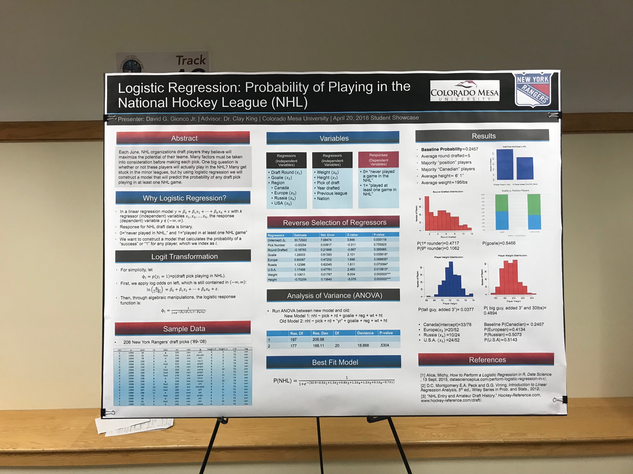

Again I’m sorry for not getting pictures with these last two presenters. I talked to about three other students along with the three I have here but only seemed to get a picture with Saige. I understand if you have to take off points because I failed to do this. But it wasn’t until late Friday night that I forgot to take some of the pictures that I needed.